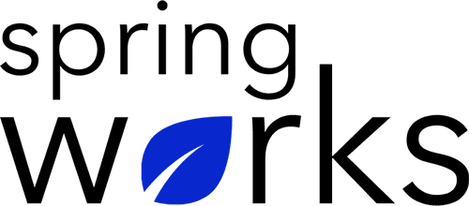
Free Template – Teamwork Satisfaction Survey

Use this survey to gain insights into how your organization is encouraging teamwork.

Analyzing how your employees are working with their teams and if they are comfortable while doing that is necessary. Here is a survey to analyze the same:

Communication (to be added as review instructions):

Your responses to this survey are anonymous. The leaders are committed to analyzing your results and taking action. Please answer this quick survey by <HOUR OF THE DAY> on <DATE>.

Thank you for your time. Your responses will help our organization become a better place to work. If you have any questions about the survey, please contact [insert name of contact person].

Demographic Information:

The following information is requested so that meaningful analysis and comparisons of group results can be made. Please check the circle corresponding to your answer.

Q: Your Gender:

- Male
- Female

Q: Your Department:

- Marketing
- Operations
- Tech
- Accounting
- HR

Q: Company Service:

- Under 1 Year
- 1-2 Year
- 3-5 Year
- 6-10 Year
- 10-15 Year
Teamwork Satisfaction Questionnaire

To answer clearly what you think or feel about each item, please follow these steps:

- Read each item fully before you start to mark your answer.
- Pick the one answer which most nearly says what you think or how you feel.
- While completing the questions, be sure to read the special instructions which are included.

Choose the most appropriate answer:

Q: My company encourages teamwork and team bonding:

- Strongly agree
- Agree
- Neutral
- Disagree
- Strongly disagree

Q: All teams are aware about their tasks and create a hard line between what they have to do vs what they don’t:

- Strongly agree
- Agree
- Neutral
- Disagree
- Strongly disagree

Q: My teammates help each other out in doubts:

- Yes
- No
- Often
- Sometimes

Q: My teammates can coordinate well with each other:

- Strongly agree
- Agree
- Neutral
- Disagree
- Strongly disagree

Q: Every teammate can voice their opinion without any fear:

- Strongly agree
- Agree
- Neutral
- Disagree
- Strongly disagree

Q: All tasks are distributed in a fair manner:

- Strongly agree
- Agree
- Neutral
- Disagree
- Strongly disagree

Q: We maintain good communication with each other:

- Strongly agree
- Agree
- Neutral
- Disagree
- Strongly disagree

Q. My teammates offer feedback to each other to help them improve:

- Yes
- No
- Sometimes
- Often

Q: Overall, I am satisfied with the coordination and bond I have with my team:

- Extremely satisfied
- Satisfied
- Neutral
- Dissatisfied
- Extremely dissatisfied

Q: Qualities of my team that I like:

i.
ii.
iii.

Q: Qualities of my team that I don’t like:

i.
ii.
iii.

Thank you for your responses!

